Server 2022 Users/Groups and NTFS Permissions
The purpose of this worksheet is to assist you in creating Users and Groups on the server. You will then use these Users and Groups as directed to demonstrate NTFS folder permissions.

Instructions
- Create the following Organizational Units (OUs), Users, and Groups on your Server 2022 VM.
  - You may assign them all the same password. Make it so the password never expires.
  - Because each of you will be working with the same server you will need to create unique OUs, Users, and Groups. One way to do this is to put your first name [fname] where indicated.
Organizational Units
Name
[fname] Sales Users
[fname] Marketing Users
[fname] Managers

Users
Name | Username | OU | Password
[fname] Boss | [fname]Boss | [fname] Managers | MSPress#1
[fname] Salesbody | [fname}Salesbody | [fname] Sales Users | MSPress#1
[fname] Marketer | [fname]Marketer | [fname] Marketing Users | MSPress#1

Groups
Name | Type | Members | OU
[fname] Manager | Global Security | [fname]Boss | [fname] Managers
[fname] Sales | Global Security | [fname]Salesbody;  [fname] Manager | [fname] Sales Users
[fname] Marketing | Global Security | [fname]Marketer;  [fname] Manager | [fname] Marketing Users
- Take the following screenshots (or snips) and paste them below each description. The screenshots or snips will show the created OUs, the groups, and the members of each group as follows:
  - [fname] Managers OU showing [fname] Manager Security Group and [fname] Boss User. Ensure [fname] Boss is a member of the [fname] Manager Group.
Paste screenshot here:
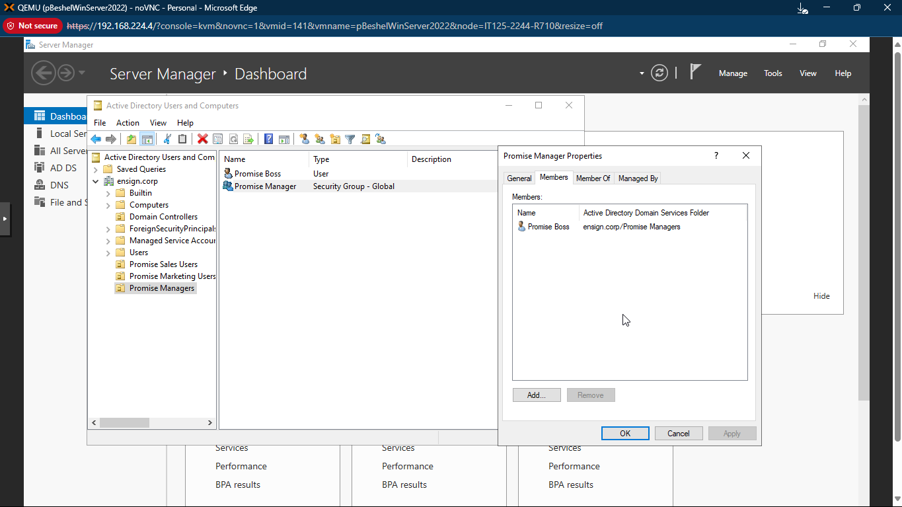

  - [fname] Marketing Users OU showing [fname] Marketing Security Group and [fname] Marketer User. Ensure [fname] Marketer is a member of the [fname] Marketing Group.
Paste screenshot here:
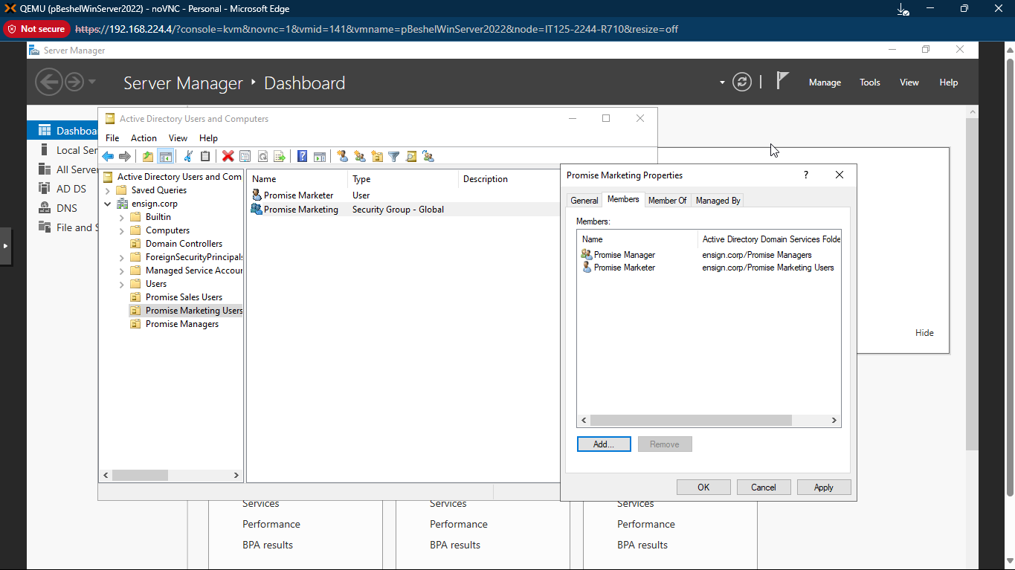

  - [fname] Sales Users OU showing [fname] Sales Security Group and [fname] Salesbody User. Ensure [fname] Salesbody is a member of the [fname] Sales Group.
Paste screenshot here:

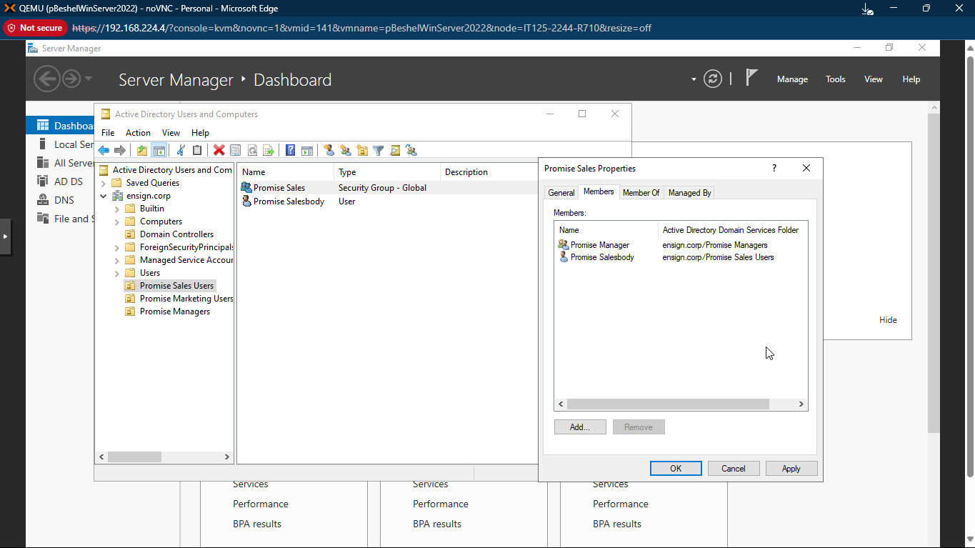
- On the C: drive of your Server 2022 Virtual Machine, create a folder named [fname] Share.
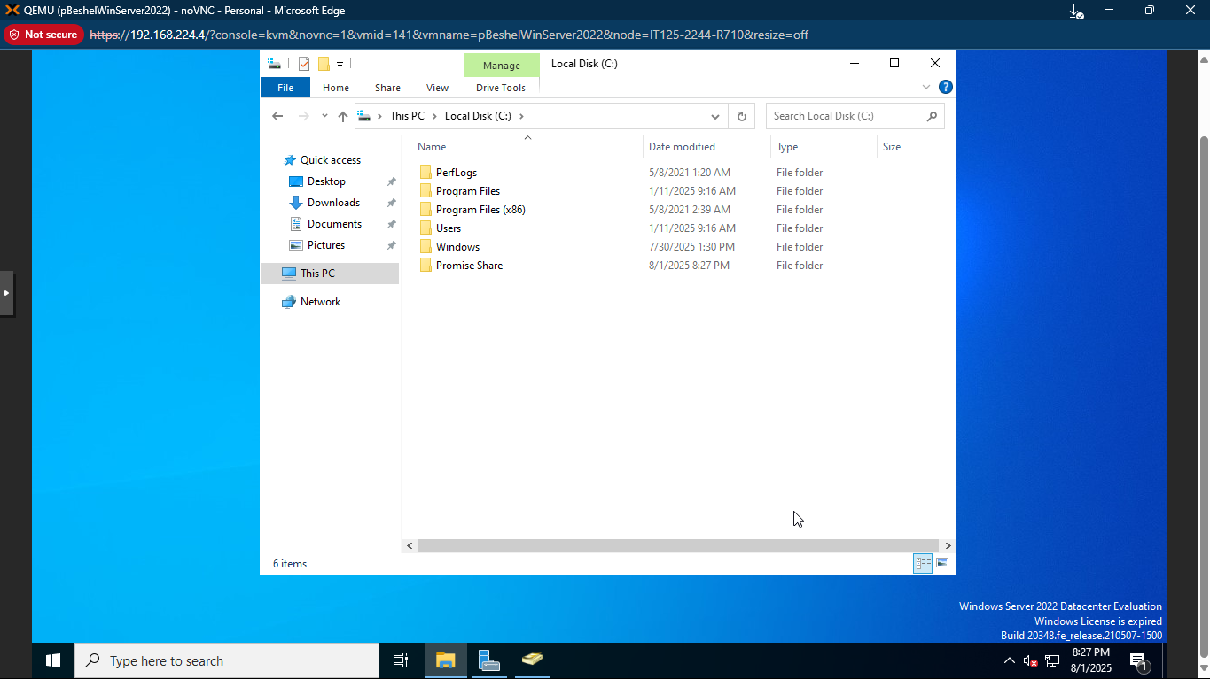
  - Share the folder with Everyone with Read/Write permissions.
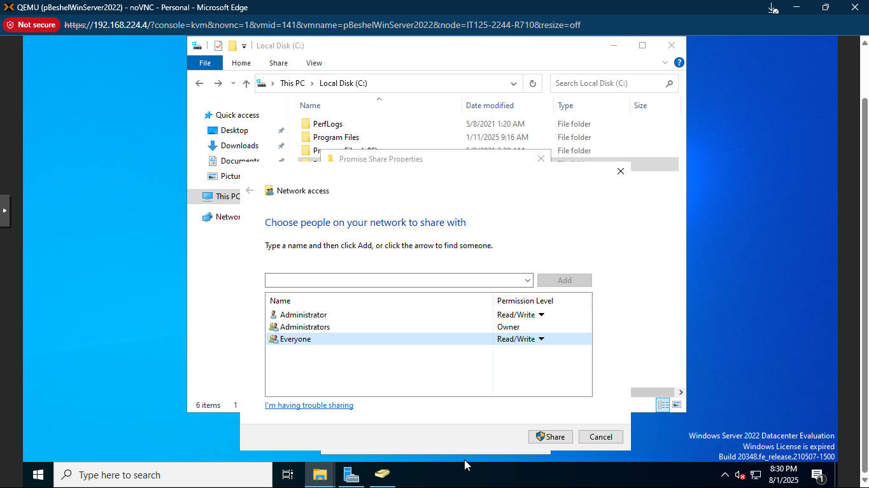

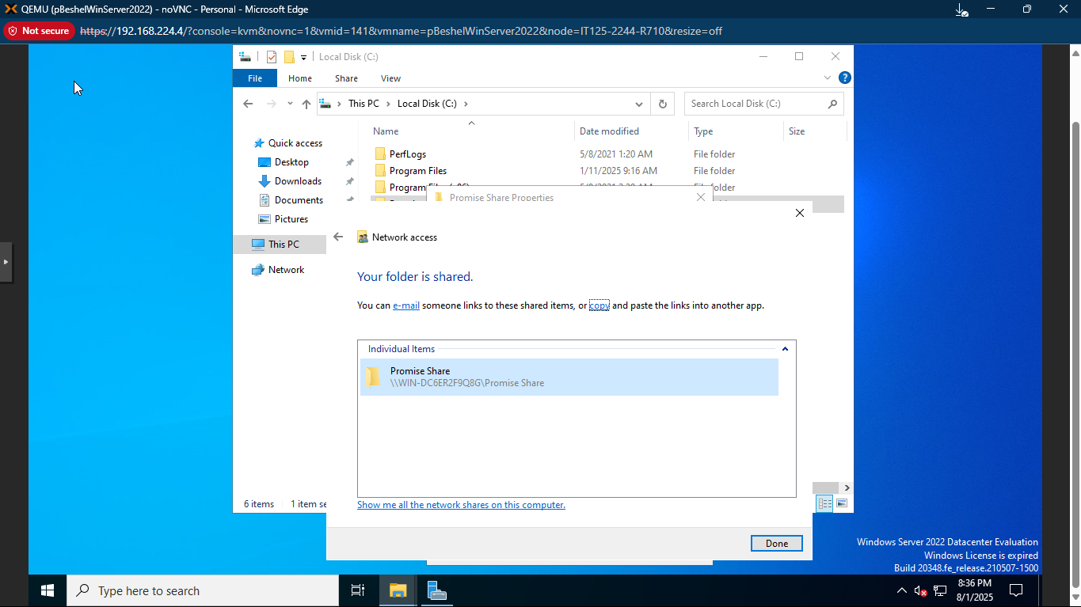
  - Make note of the Network Path of the Share folder:
\\WIN-DC6ER2F9Q8G\Promise Share
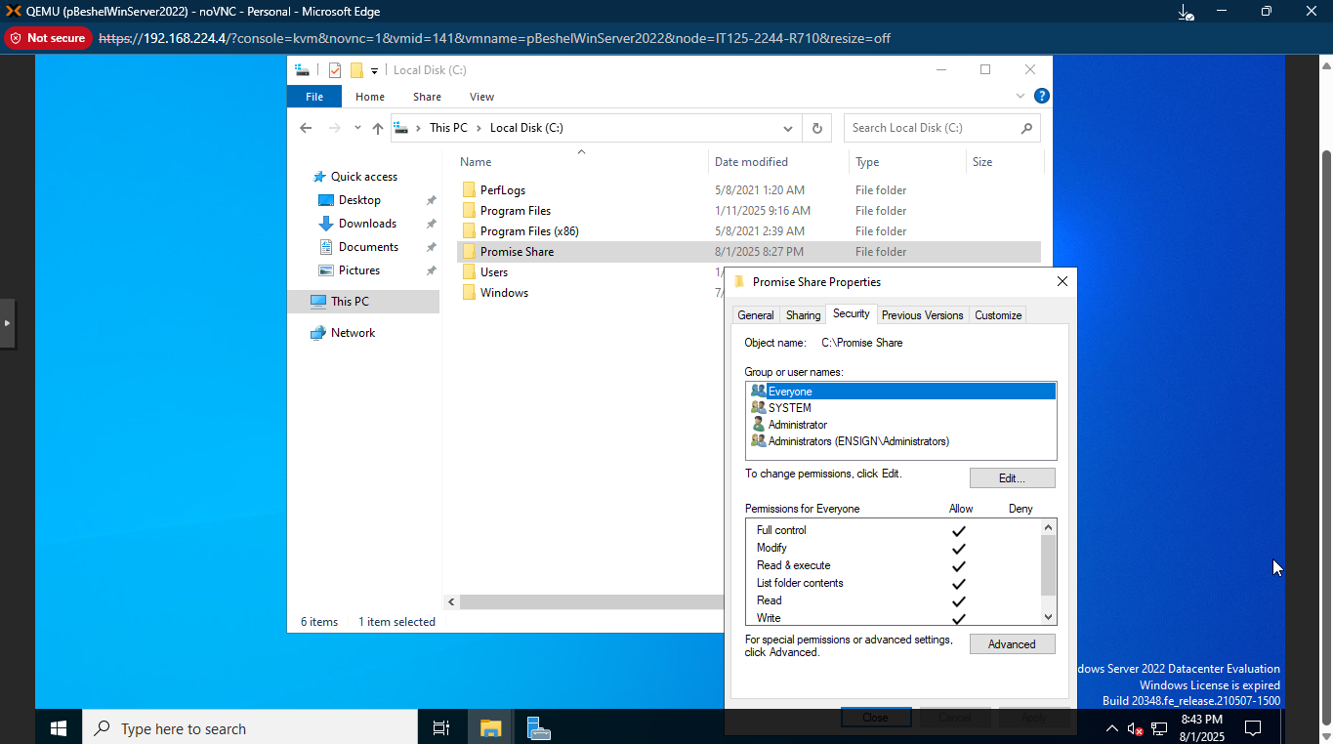

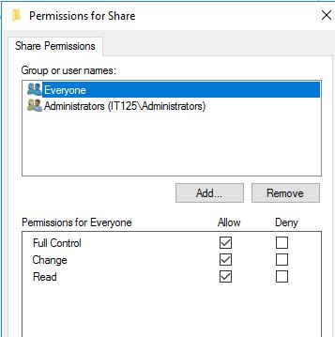
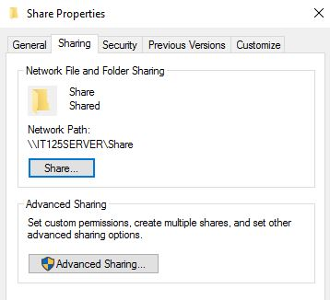

- Within the [fname] Share folder, create [fname] Sales and [fname] Marketing folders.
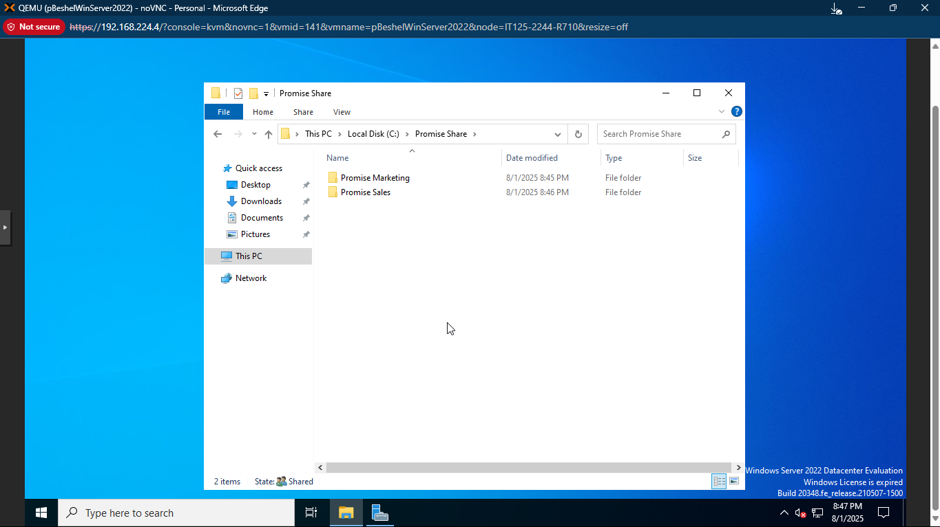
  - In the [fname] Sales folder, create a text file named Sales Document.
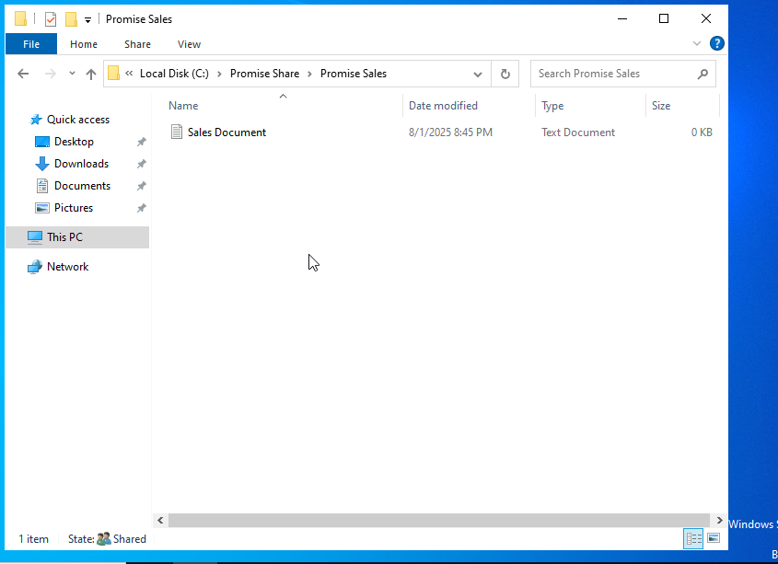
  - In the [fname] Marketing folder create a text file names Marketing Document.

  - 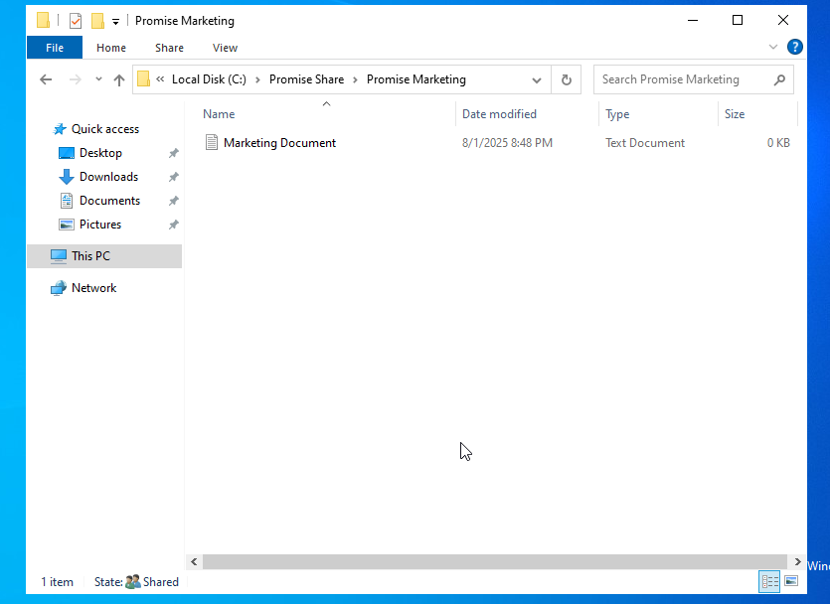
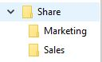
  - You will not need to set share permissions as they will inherit the permissions from the parent folder.
- You should have learned how to access shared files in previous projects. If you have forgotten how, please refer to earlier projects or research online how to accomplish this.
- Switch over to your Windows 11 machine and log in as [fname]Marketer. You should be able to access both of the documents.
- Switch back to the Server 2022 VM.
  - Edit the security setting of the [fname] Marketing folder.
  - Disable inheritance and convert inherited permissions to explicit permissions.
  - Remove the Everyone group.
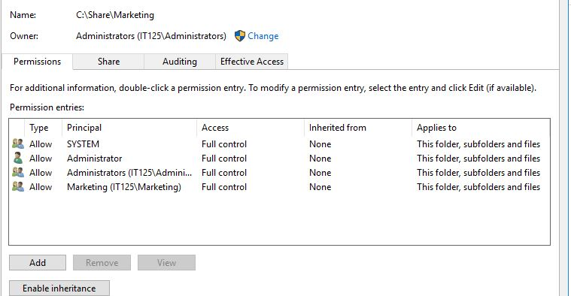
  - Add the [fname] Marketing security group and grant Full Control.
- Edit the security setting of the [fname] Sales folder.
  - Disable inheritance and convert inherited permissions to explicit permissions.
  - Remove the Everyone group.
  - Add the [fname] Sales security group and grant Full Control.
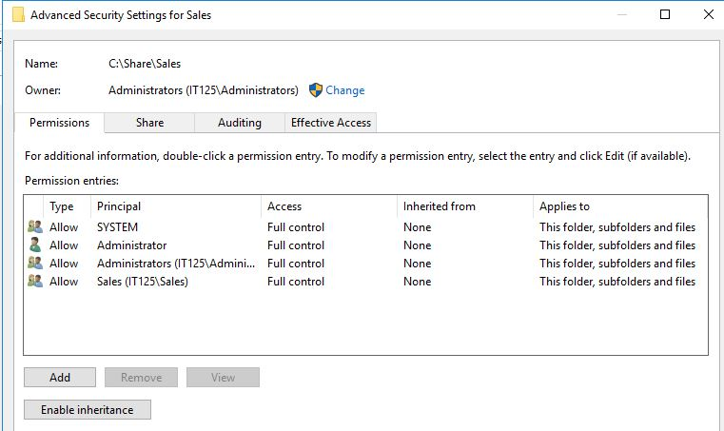

- Switch back to the Windows 11 VM.
  - Attempt to access the [fname] Marketing folder as before. You should be successful.
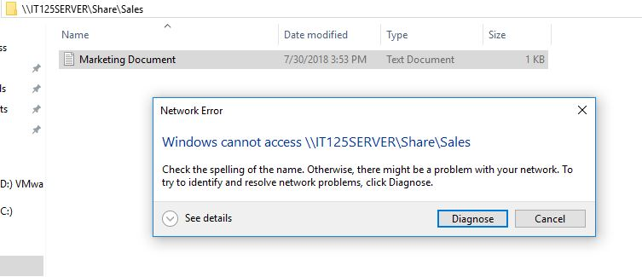
  - Attempt to access the [fname] Sales folder. You should get the following error:

You may only see the [fname] Marketing folder. Take a screenshot showing [fname] accessing the [fname] Marketing folder.
Paste screenshot here:

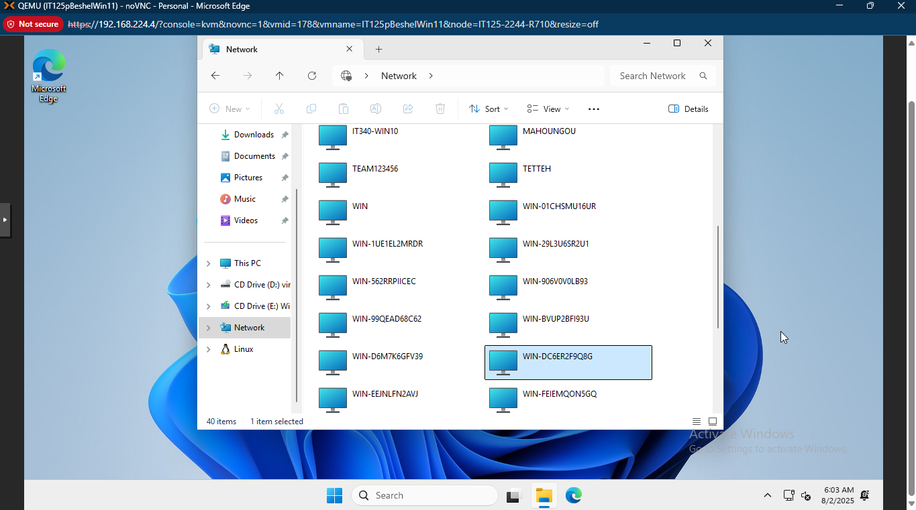
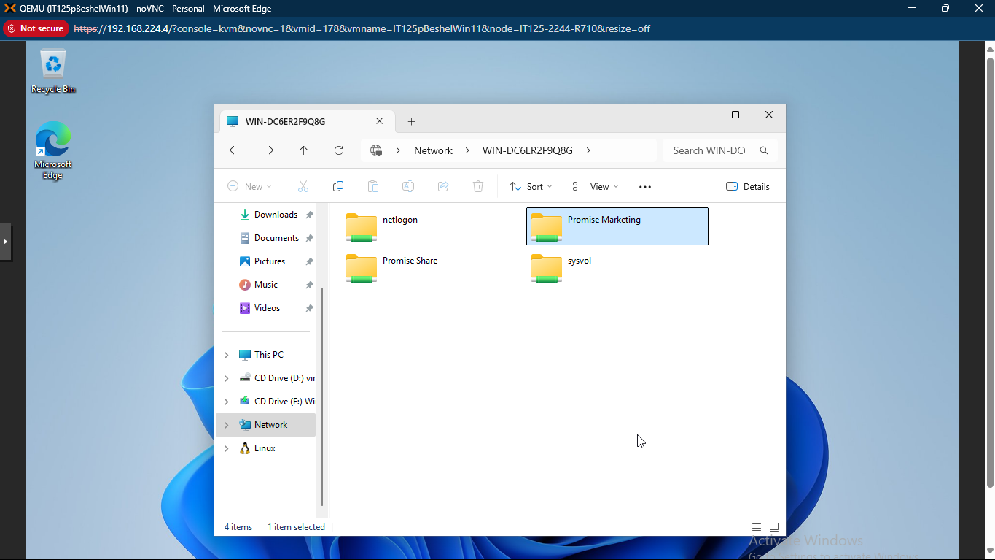
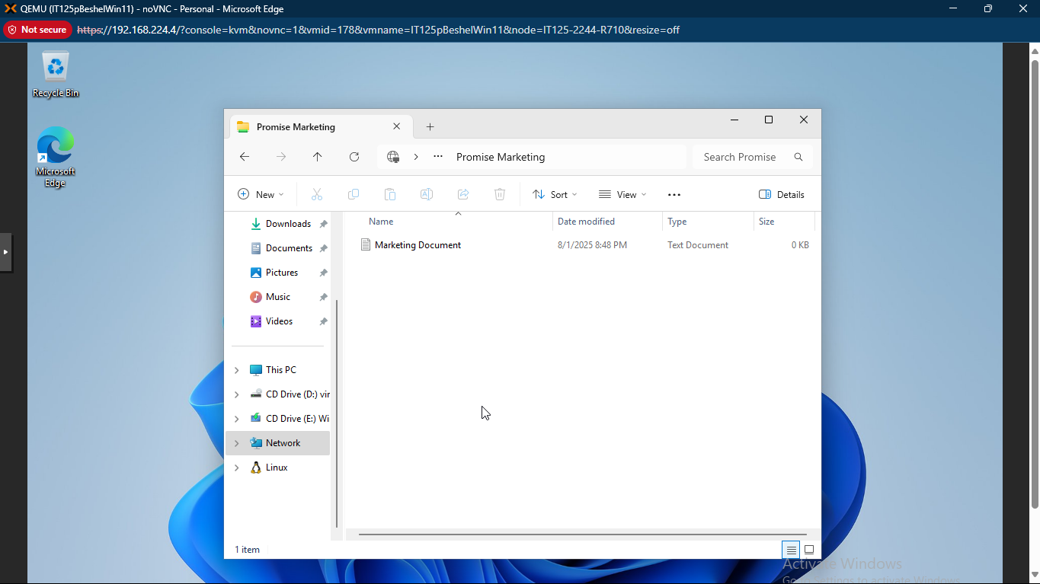

- Switch user to [fname] Salesbody.
  - Attempt to access the [fname] Sales folder. You should be successful. You should not even see the [fname] Marketing folder.

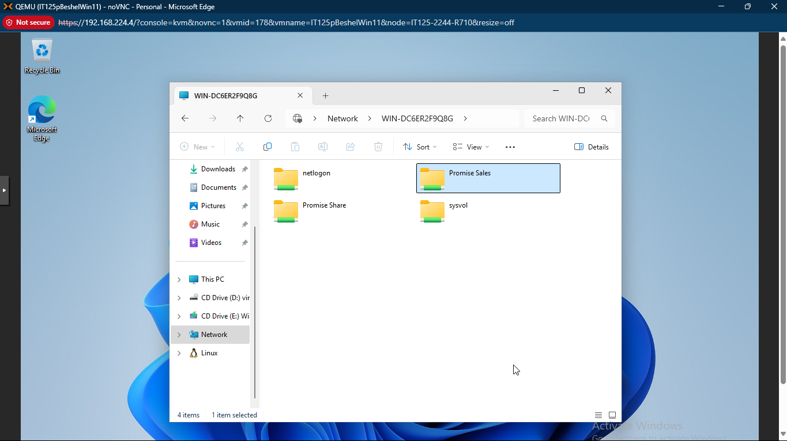
  - Take a screenshot of [fname] Salesbody attempting to access the [fname] Sales folder.
Paste screenshot here:

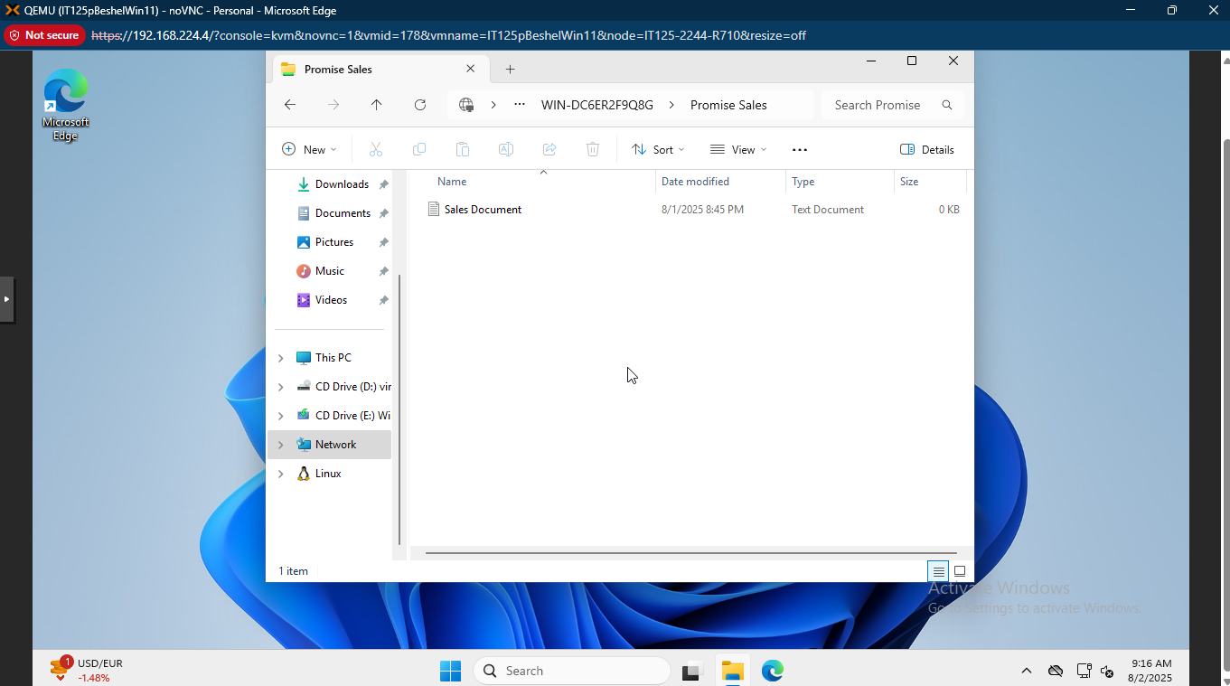

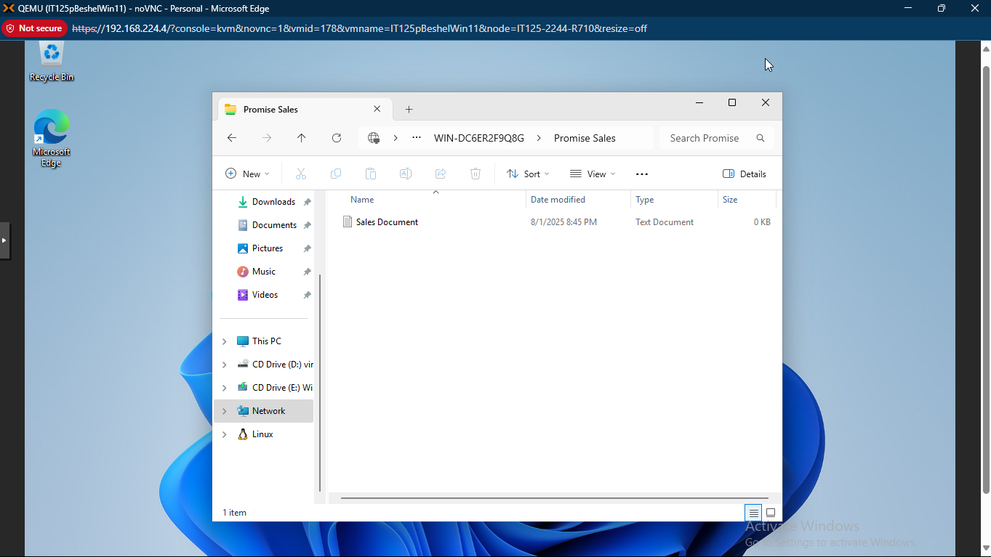

- Switch user to [fname] Boss. This user should be able to access both folders and documents. Take the following screenshots:
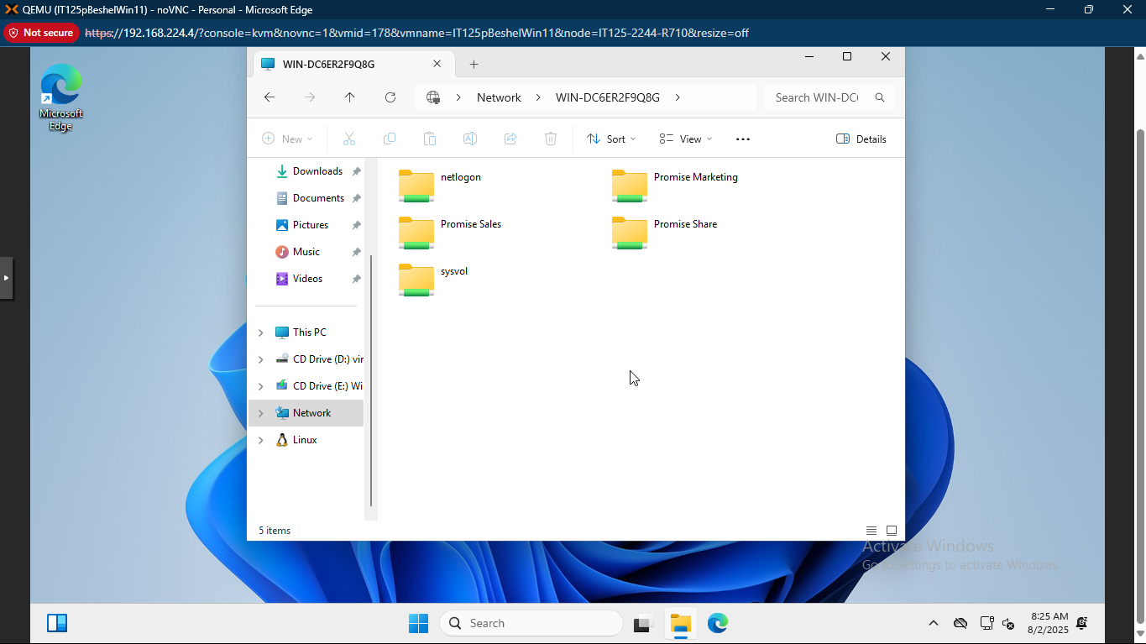

  - [fname] Boss attempting to access [fname] Marketing folder.
Paste screenshot here:
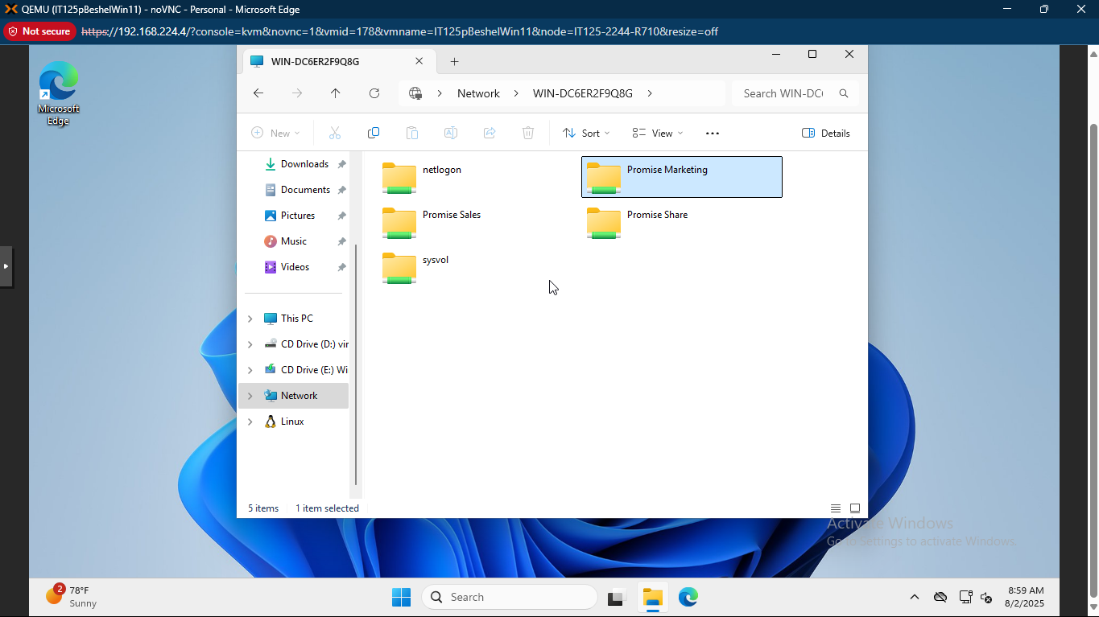


  - [fname] Boss attempting to access [fname] Sales folder.
Paste screenshot here:
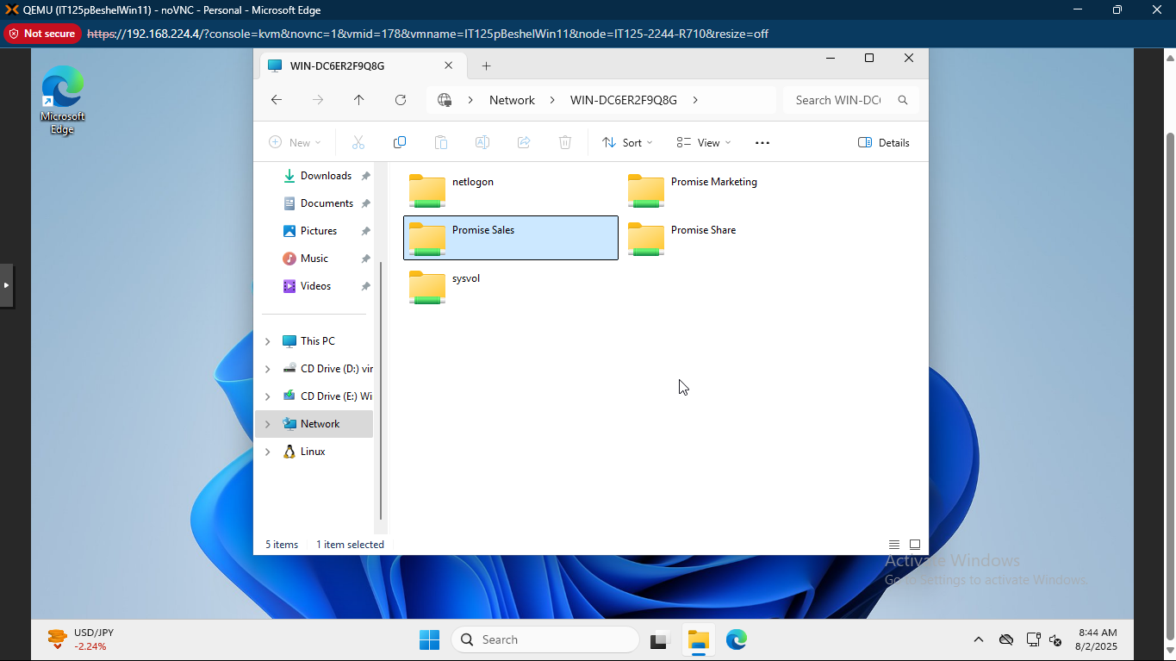
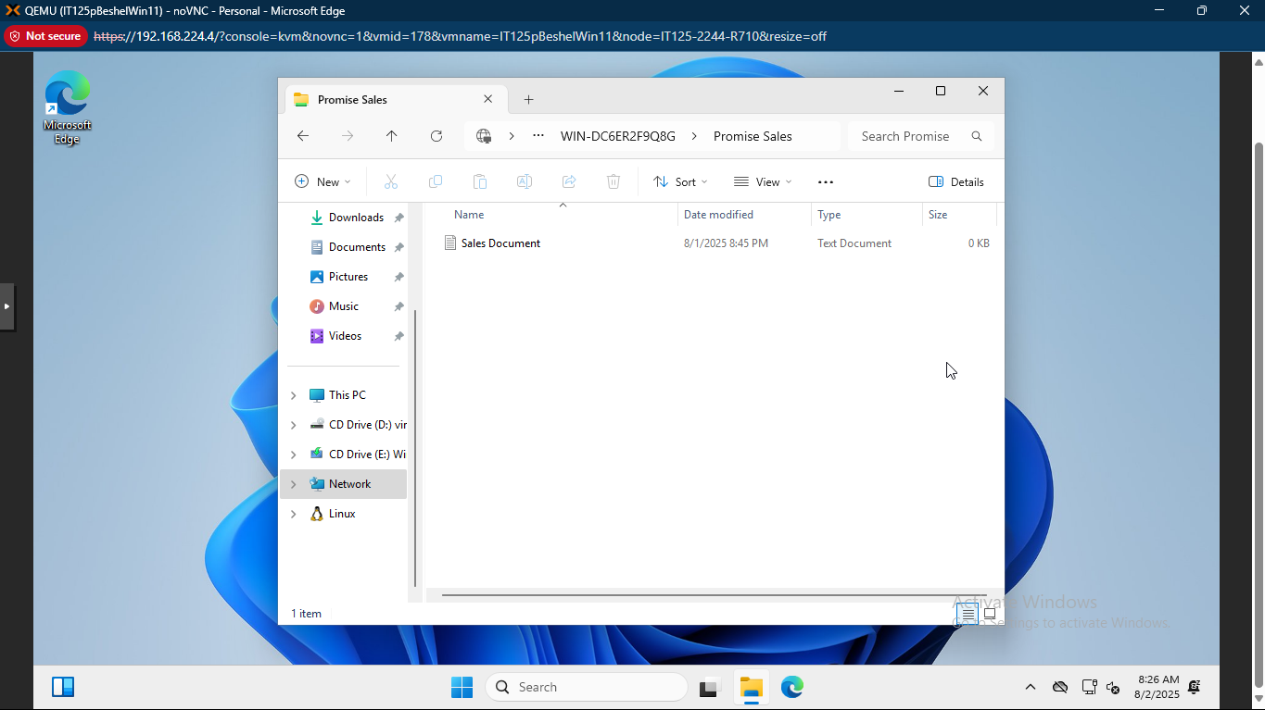

- Submit this completed worksheet in Canvas for assignment credit, including the 7 required screenshots in steps 2, 9, 10, and 11.
Reflection
Completing this worksheet was a valuable learning experience. Setting up users, groups, and permissions on Server 2022 provided hands-on insight into Active Directory and NTFS permissions. I found the process of creating organizational units and configuring folder permissions particularly enlightening, as it demonstrated the importance of proper access control in a networked environment.
One challenge I faced was troubleshooting access issues when switching between user accounts on the Windows 11 VM. Ensuring the correct credentials and permissions were in place required careful attention to detail. There were those moments when my outcomes did not match the expectations (from the instruction set), so I had to go back to redo the task to match the expected outcome, tweaking the necessary configurations where need be.
I would like to learn more about advanced Active Directory features, such as group policy management and automation tools for user and group creation. Additionally, understanding best practices for securing shared resources in larger networks would be beneficial.

